HIDDEN ACTIVE CELLPHONE DETECTOR

ABSTRACT

The main scope of project is to sense the presence of an activated mobile phone from a distance of one-and-a-half meters to prevent the use of same in the examination halls.
Certain places where uses of mobile phones are not allowed like exam hall, temple, offices and theaters, in those places to detect and restrict the use of mobile phones this proposed system is very helpful. This system can detect any active cell phone i.e. when some is trying to make a call or receive a call, sending a message or receiving a message. In the above mentioned conditions a buzzer will sound, in the presence of an active cell phone in the radius of one and half meters.
In this project an RF detector using tuned LC circuits is formed for detecting signals in the GHz frequency band used in mobile phones as the transmission frequency of mobile phone ranges from 0.9 to 3 GHz.
A capacitor is used to form a part of the LC circuit as C while the lead of the same forms the L to receive RF signals from the mobile phone. When the mobile phone is activated the RF transmission signal is detected by the detector and starts sounding a beep alarm and the LED blinks.

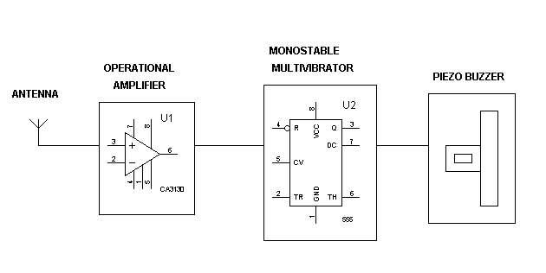
BLOCK DIAGRAM:
HARDWARE REQUIREMENTS:
OP amp, 555 Timer, Transistor, LED, Resistors, Capacitors, Piezo buzzer, Switch, Battery, Antenna.

